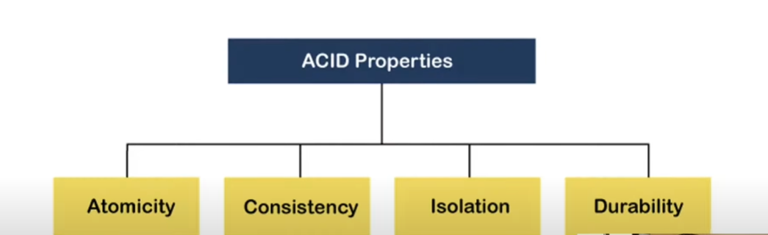

A [**transaction**](https://www.geeksforgeeks.org/sql-transactions/) is a single logical unit of work that accesses and possibly modifies the contents of a database. Transactions access data using read and write operations.   
In order to maintain consistency in a database, before and after the transaction, certain properties are followed. These are called **ACID** properties.

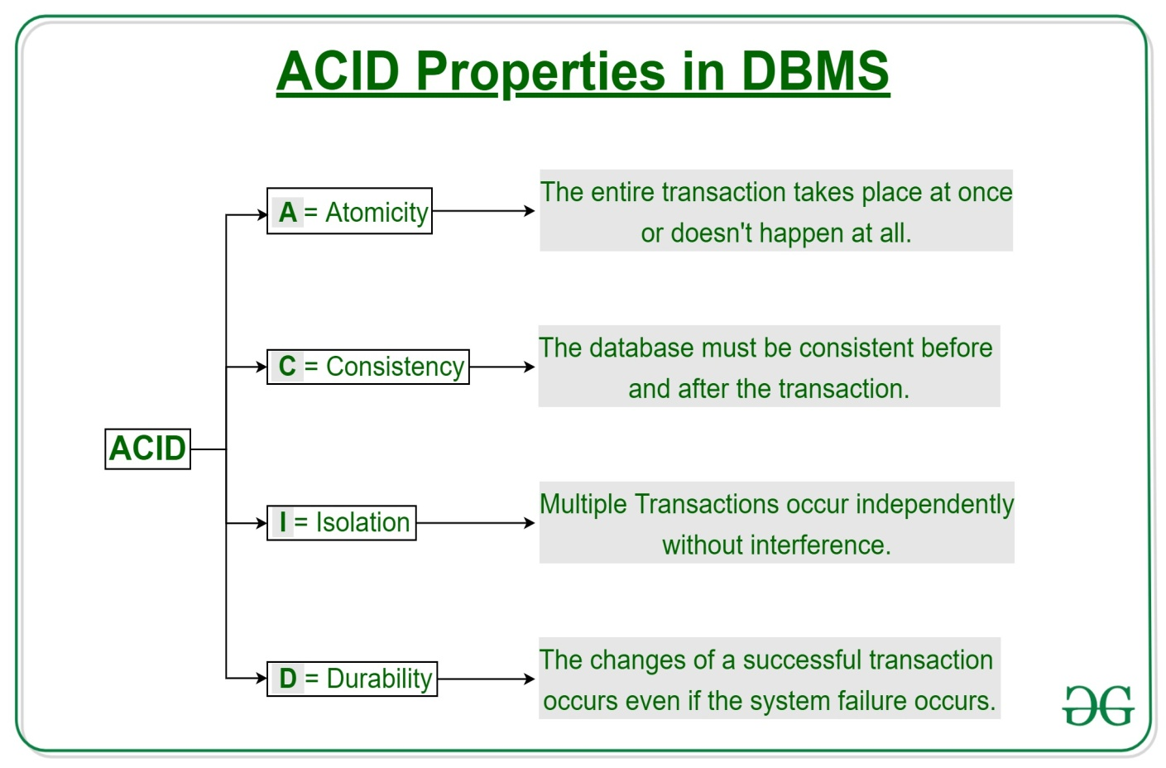

**Atomicity:**

By this, we mean that either the entire transaction takes place at once or doesn’t happen at all. There is no midway i.e. transactions do not occur partially. Each transaction is considered as one unit and either runs to completion or is not executed at all. It involves the following two operations.   
—**Abort**: If a transaction aborts, changes made to the database are not visible.   
—**Commit**: If a transaction commits, changes made are visible.   
Atomicity is also known as the ‘All or nothing rule’.

Consider the following transaction **T** consisting of **T1** and **T2**: Transfer of 100 from account **X** to account **Y**.

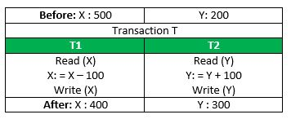

If the transaction fails after completion of **T1** but before completion of **T2**.( say, after **write(X)** but before **write(Y)**), then the amount has been deducted from **X** but not added to **Y**. This results in an inconsistent database state. Therefore, the transaction must be executed in its entirety in order to ensure the correctness of the database state.

**Consistency:**

This means that integrity constraints must be maintained so that the database is consistent before and after the transaction. It refers to the correctness of a database. Referring to the example above,   
The total amount before and after the transaction must be maintained.   
Total **before T** occurs = **500 + 200 = 700**.   
Total **after T occurs** = **400 + 300 = 700**.   
Therefore, the database is **consistent**. Inconsistency occurs in case **T1** completes but **T2** fails. As a result, T is incomplete.

**Isolation:**

This property ensures that multiple transactions can occur concurrently without leading to the inconsistency of the database state. Transactions occur independently without interference. Changes occurring in a particular transaction will not be visible to any other transaction until that particular change in that transaction is written to memory or has been committed.

**Durability:**

This property ensures that once the transaction has completed execution, the updates and modifications to the database are stored in and written to disk and they persist even if a system failure occurs. These updates now become permanent and are stored in non-volatile memory. The effects of the transaction, thus, are never lost.

**Some important points:**

| **Property** | **Responsibility for maintaining properties** |
| --- | --- |
| Atomicity | Transaction Manager |
| Consistency | Application programmer |
| Isolation | Concurrency Control Manager |
| Durability | Recovery Manager |

The **ACID** properties, in totality, provide a mechanism to ensure the correctness and consistency of a database in a way such that each transaction is a group of operations that acts as a single unit, produces consistent results, acts in isolation from other operations, and updates that it makes are durably stored.